BABEŞ-BOLYAI UNIVERSITY CLUJ-NAPOCA

FACULTY OF MATHEMATICS AND COMPUTER SCIENCE

SPECIALIZATION COMPUTER SCIENCE

DIPLOMA/ DISSERTATION THESIS

Computer Assisted Training in a Real Life and VR Environment using HIIT

**Supervisor**

**Assoc. Prof. Rareș Florin Boian, PhD**

Author

Alexandru-Bogdan Sabadus

**2021**

Contents

**1** **Introduction** 1

1.1 Description 1

1.2 Relevance 1

1.2.1 Importance 1

1.2.2 Benefits 2

1.2.3 Existing Products 3

1.2.4 Contributions 4

1.3 Thesis Description 4

**2** **Notions** 6

2.1 Fitness & Health Terms 6

2.2 Virtual Reality 7

**3** **Existing Literature** 11

3.1 Description 11

3.2 Fitness Literature 11

3.3 VR Literature 13

3.4 Takeaways 14

**4** **Theory** 16

4.1 Description 16

4.2 VO2max predictions 16

4.3 Hearth rate equations used 18

4.4 Algorithms 19

**5** **Application** 22

5.1 Motivation & Approach 22

5.2 Technologies & Brief Description 23

5.3 System diagram 24

5.4 System description 28

**6** **Evaluation** 29

6.1 Data Collection 29

6.2 Results 29

6.3 Discussion 29

**7** **Conclusion** 30

**8** **Bibliography** 31

# **Introduction**

## Description

In my Bachelor Thesis I decided to tackle a more complex topic combining multiple subjects that I am interested in: fitness, computer science, virtual reality, algorithms, artificial intelligence and multiple programming languages and paradigms. The multiple subjects are due to the fact that I want to incorporate as much as I can and learned throughout my university years and my professional times.

The application the thesis includes consists of trying to use sensors to monitor the fitness, during physical activity in VR and real life, of an individual and the amount of effort put into such a workout, consisting of any exercises, and try to optimize it according to the data received. The basic workout routine will follow the H.I.I.T(Hight Intensity Interval Training) paradigm. The data necessary refers to the Hearth Rate, Sweat Levels and Oxygen Consumption based on the EPOC prediction method. [1]

For it to be an actual product, I shall use some of the technologies accessible at large, for example, the sensor(hardware) part will be done on a simple fitness smart watch, mostly because the portability of this device. The VR environment shall be developed using Unity, because of the ease of use. Regarding the processing of the data and how the applications will communicate with each other, a simple WebSocket server will be hosted locally, collecting, processing and sending data. The latter part containing the main logic behind the whole system.

## Relevance

### Importance

The importance of the subject of the thesis is given by the major role played by fitness in the everyday life of a person in regards to the mental and physical wellbeing of that person in general and in the cases of chronic diseases [2]. In addition, because of the context of the current pandemic, during which the thesis is written, the VR aspect of the thesis becomes more and more relevant as the places designated for physical activity become a hazard for everyday life as there is a higher risk of infection, both direct, infectious droplets resulted from coughing and sneezing, and indirect, touching of infectious surfaces, and in some cases the decisions of the government to close down such places as gyms.

It follows that, most people have lost their usual place where they conduct such physical activities and are forced to move indoors if they are to continue. Moreover, due to that fact they lose an important part of that process, the social interactions, which can help the state of mind of that person by participating in prosocial activities [3] and due to no external stimuli being present, for example seeing the progress in others, physical activity may dwindle.

Lastly, in a more pessimistic view, being able exercise almost everywhere to a somewhat reasonable intensity to result in weight loss, may encourage some individuals to change a part of their daily activity and incorporate physical exercises in it, resulting in a healthier lifestyle in general, for the simple fact that one of the most prominent justification for not participating in physical activities is based on the lack of proper equipment.

### Benefits

I theorize that, because of the ease of use of this VR environment, in regards to optimizing an in-house workout routine for weight loss through the H.I.I.T program, plus the jovial nature of some of those routines (VR Boxing, VR Tennis, VR Dancing, etc.), a lot more people will start getting involved in fitness and physical activity in general, leading people to a healthier lifestyle and, in turn, raise their happiness level, since there is a clear correlation between those two [4].

In addition to the benefits regarding the everyday life of people, because of the lackluster amount of research done when it comes to the subject of physical activity in a VR environment, a general consensus regarding the effectiveness of this has not yet been formed by the scientific community at large and there are still a lot of unknown factors that could lower or improve that. This paper also tries to provide more data and a different perspective on that subject, hoping that it may benefit and encourage future research.

On another note, because of the nature of the subjects being very dissimilar, VR and Fitness, having in common only the fact that both activities are focused on the human body at some extent, I believe it could encourage others to search for and maybe discover correlations between other polarizing science topics and help guide people to a better understanding of those.

### Existing Products

As per existing products that try to achieve an optimization of the user workout in a VR environment, there exist only apps that allow the user to do a basic workout routine using the M.I.C.T (Moderate-Intensity Continuous Training) model, e.g. boxing games [5] [6], archery games [7], etc.. What all those have in common is that they do not use any algorithm or additional sensors to improve the efficiency of the physical activity during them, meaning that there is little control over the user’s physical activity and no way to tell if the “workout” is performed at the best capacity it can be.

In addition to that, in the article “The Thrill of the Fight Game Review – The Ultimate VR Boxing Workout”, by Kevin Brook in the journal VR Fitness Insider, there is a graph, represented in Figure 1.1, showing the effectiveness of the physical activity done during a play session of the game “The Thrill of the Fight” [8]. For most people, an entire activity lasting 44 minutes can be very hard to fit in a tight schedule, no matter how effective it was at creating a calorie deficit. For that reason, H.I.I.T can even be integrated even in high performance athletes, being a better alternative, because of that fact that it can be done in a much quicker interval and produces the same effects, and is some situations event better results [9], than the alternative counterparts.

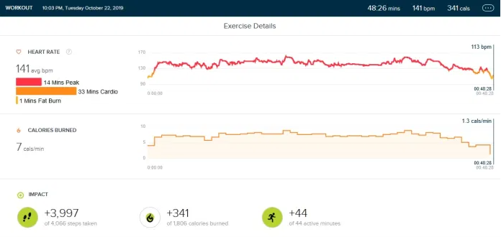Figure 1.1 - Reference graph to the article by Kevin Brook [5]

### Contributions

The thesis subject was chosen with the help of the Assoc. Prof. Rareș Florin Boian. The physical metrics were measured by the Author the thesis, along with the analysis of the data. The applications used were developed also by the Author.

## Thesis Description

In the 2nd chapter there are some definitions of the big notions used in the thesis, in short building a foundation of understanding of the subjects at large.

After that comes the Existing Literature in which there is a presentation the systems, algorithms, and approaches that have a reasonable degree of association with the chosen subject of the thesis. Also, in the same chapter we look existing systems in regards to the pros and cons of those in relation to this thesis and in general, and finally concluding some of the key takeaways from the study of the literature.

The Theory chapter presents, in detail, the theoretical aspects (algorithms, architecture, etc.) used or from which the approach of the thesis was inspired from.

The Application part of the thesis details the use of the app including: the architecture, diagrams, use-cases, user-manual etc. In addition to that, we also list and detail some of the technologies/frameworks used.

The Evaluation part refers to the data processing part of the thesis in which we describe the data collection part, how it is done, what kind is used, and of what importance it is. After analyzing the processed fitness data from the workout and coming up with some results from that data, it follows a discussion regarding the positive, negative or peculiar aspects revealed through that data.

Finally, there is the Conclusion chapter which tries to summarize what has been done, the contributions, and the results.

# **Notions**

## Fitness & Health Terms

Excess Post-Exercise Oxygen Consumption is the term for the period after an exercise in which there is a significant increase in VO2(Oxygen Uptake) [10], which leads to an increase in calorie consumption. In more broader terms, during the exercise the body consumes an elevated amount of oxygen due to the high stress is put under because of the intensity. It follows that, the body is „owed” an oxygen debt to replenish energy and return to a normal state, because of that, the body will: use immediate sources of energy as ATP, re-oxygenate blood cells, start decreasing the body temperature and finally returning to normal ventilation [11].

Maximal oxygen uptake, denoted as VO2max, is one of the metrics when trying to measure the intensity of an exercise and/or a workout routine in athletes. It shows the maximum amount of oxygen an athlete can use during an exercise and it is most used when trying to determine the aerobic endurance and it is close related to cardiovascular fitness and performance capacity [12]. This measurement is used due to its close link to exercise intensity and follows the premise that the more oxygen is consumed by the athlete during the workout, the body will need to generate adenosine triphosphate (ATP), in contrast with E.P.O.C(Excess Post-Exercise Oxygen Consumption). Though different kinds of measurement, by the nature of the object they measure, used together they can form a model which can predict the recovery rate of the athlete post-exercise [13] and the maximum intensity at which a workout routine can be performed for maximum efficiency.

In fitness there are a lot of workout routines based on the physical intensity and stress of the particular exercises out of which a workout consists of e.g. M.I.C.T. (Moderate-Intensity Continuous Training), H.I.I.T. (High-Intensity Interval Training), RT (Resistance Training) etc. As such, for the purposes of this paper, we will only look at one type of workout routine H.I.I.T. Due to the multiple definitions of such a routine, describing multiple intervals of rest and activity much like in Figure 2.1, a much broader definition must be used. H.I.I.T. is a high-intensity exercise with aerobic intervals, that can be either a full rest state or a more low-intensity alternate of the same exercise, that aims to have an intensity, measured in terms of maximal oxygen uptake (VO2max), between the values of 80%-92.5% of the peak hearth rate. [14] [15] [16]

Figure 2.1 – Visual description of H.I.I.T. exercise intensity over time

All of those indicators, even though they do not correlate as much as we are led to believe to a higher weight loss [17], most of the performance metrics of those who undergo H.I.I.T. on a regular basis are in comparison to those with a more simpler workout regimen, like weight lifting [18], an equal part of the positive effects come from the physiological aspect [19] of fitness and the perceived progress of the individual has a big part to play in the discussion of the effectiveness, most like any sport, and just like it should be practiced with care, factoring in the risk of injury.

## Virtual Reality

The concept of Virtual Reality(VR) can be traced back to the middle of the 20th century when Ivan Sutherland tried to describe a type of display that made the user experience a virtual world more authentic, more specifically, he was describing VR as a window through which the user can perceive the virtual world being immersed in it [20], as if there was no barrier between the virtual and the real. Moreover, the user could interact with everything in the virtual world and that object would act as it’s real world counterpart, basically obeying our understanding of physics.

Since that first brief and abstract description of what we call now VR there have been multiple definitions of what VR actually is, taking into account the application of it with our current technology, for example, in 1992 Fuchs and Bishop defined VR as “real-time interactive graphics with 3D models, combined with a display technology that gives the user the immersion in the model world and direct manipulation” [21], which, aside from being a simple and brief definition can incorporate much of what that medium has to offer. Moreover, this medium emphasizes the perception of the environment, the interactions with it, and most importantly, the immersion of the user [22]. In addition, these days there is a lot of additional equipment to a VR Headset with their only purpose is to enhance the experience of the user in the virtual medium and emulate, as close as possible, the real counterpart of those experiences, for example: VR Suits that help the virtual environment track the user and imitate his movements more accurately, Haptic Gloves that can help with tracking precise hand gestures and movements while also emulating the weight of the object the user is holding, Haptic Masks that help with simulating smells, vibrations and other tactile sensations etc. [23].

With all those gadgets that help immersion there has been a categorization, based on the degree of the immersion felt by the user [22]

* Simple and Non-immersive, where a VR headset is not involved, instead they use a desktop to reproduce the environment
* Simple and Immersive, where a Head Mounted Display (HMD) is used along with other additional devices, mostly haptic ones, to recreate the real world
* Simple and Semi-immersive mostly consisting using head-tracking rendering providing stereo image of a 3D scene displayed on a monitor, this category being between the two above, e.g. Fish Tank VR [24]

All those categories listed above are important to the evolution of such a virtual medium, because they represent the degree to which the user feels present in the virtual world. As such there are multiple definitions of presence in literature [25]:

* Presence in terms of social interactions, where presence is an attribute of a medium as it is perceived as sociable, intimate, personal [26]
* Presence in terms of how it can reproduce a medium that has all the properties of the world we live in, thus feeling real
* Presence in terms of transportation. With regard to film, the famous 2010 Nolan movie Inception [27] uses this definition of perception in the main plot of the movie to establish the main theme as it being dreams and how that medium can be perceived as authentic as real life, because the exceptional capacity of the brain to recreate all the necessary types of experiences for the person to misinterpret everything as real
* Presence in terms of immersion, being defined as “the degree to which a virtual environment submerges the perceptual system of the user” by Biocca and Delaney in their book Communication in the Age of Virtual Reality [28]
* Presence as social actor within medium
* Presence as medium as social actor

Because of the variation of the definition in literature and the fact that they the same idea, the only thing that differentiate one from the others is how perception is perceived, in terms of what paradigm or type of science, Short, Williams, and Christie, in their paper “*The social psychology of telecommunications”,* use communication as a base reference. The best example of this being the last two categories, “Presence as social actor within medium” and “Presence as medium as social actor”. For this reason, Lombard and Ditton try to encompass all those definitions in a simple phrase “Each represents one or more aspects of what we define here formally as presence: the perceptual illusion of nonmediation” [25]. In simpler terms, they refer to the continuous exposure of the subject to an environment, with the existence of such a medium not being perceived and the subject acting as if it wasn’t there. Even though each social interaction between two persons is being held within a medium, because of our perceptual systems, they refer to nonmediated in regards to the absence of human technology.

Because of those factors there have been studies trying to combine VR and Fitness. Since fitness is well known to improve the physiological and psychological state of a person, thus there have been previous efforts to prove that those can be reproduced if the environment is not the traditional one, e.g. Fitness Gym. Even though, it seams to be clear that there is a positive impact to Fitness in a VR environment [29], the quality of the exercises compared to the traditional cannot be determined as there are not enough studies.

# **Existing Literature**

## Description

Since most of the subjects presented in the thesis were, in some manner, touched in the Notions chapter of the thesis, for a better understanding of the terms that are going to be used, this chapter is going to explain in more detail the methods and systems used, cross-examining with already existing literature. For that reason, this chapter will cover different types of VO2max measurements and their efficiency at determining it, past studies of determining the efficacy of VR Fitness and their results, along with their impact on the subject as a whole, and other documented types of Computed Assisted Training.

## Fitness Literature

There are multiple formulas for computing the VO2max that may be applied for different types of exercises [30]. As a start, the early work of Astrand and Ryhming in 1954, in their paper “A Nomogram for Calculation of Aerobic Capacity (Physical Fitness) From Pulse Rate During Submaximal Work” [31], hypothesizes that, due to the metric’s close relation to the power outage measured in watts, more specifically, since the ergometers at that time did not read the physical effort in watts, in kg-m/min (kilogram-force meter / minute), they could discover an equation such that they could accurately predict the result with a high enough confidence interval that it could be used. Other papers tried the same approach in approximating the metric and yielded same results, mostly within a reasonable confidence interval as it is shown in Figure 3.1, all the data points being close to the diagonal line representing the expected output. Contrary to the study, it has to be outlined that, even though it was one of the first studies the possibility of such an equation, it still had some flaws regarding a small sample size and a poorly defined exercise protocol, but still manages to provide the ground work for many of the future literature regarding this subject [30] [31].

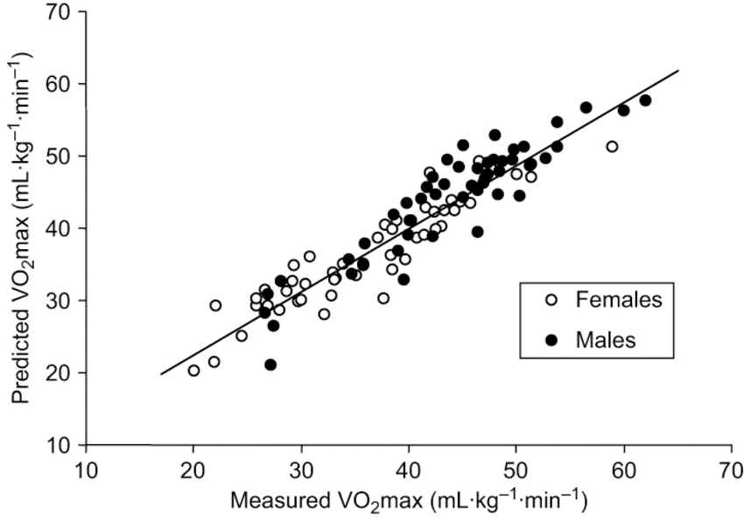

Figure 3.1 - Predicted VO2max vs. measured VO2max scatter plot from the article “Prediction of Maximum Oxygen Uptake Using Both Exercise and Non-Exercise Data” [40]

Later, in 1990, a paper by Storer, Davis, and Caiozzo entitled, “Accurate prediction of VO2max in cycle ergometry” tried contributing to that idea and came up with an equation which, based on the CE (cycle ergometry) VO2max metric and its more direct connection to watt outage. Their findings suggest that “for a 15 W.min-1 CE GXT provides accurate estimates of VO2max” [32], GXT being graded exercise test. They also concluded the fact that their prediction method has an output within 10% of the real value. The hypothesis was reinforced by other research and by one particular article from a fitness blog comparing different VO2 estimation techniques [30].

Another, more straightforward estimation using the heart rate ratio method outlines the relation between VO2max and cardiac output. The used method of obtaining such results is described as so in the paper, measuring the HRrest (lowest value of any 1-minute average during the measuring period) value during a 5-minute period and the HRmax (maximal 5 second average during a treadmill test) [33]. This study also found a proportionality factor between the HRmax/HRrest and VO2max being of about 15.3 [33]. Moreover, it also gives importance to HRrest and HRmax values as fitness indicators. In contrast to the study, 2 flaws stand out, the first being that of the error zone for such an estimate in comparison with the previously analyzed method, the other one the small sample size of the individuals used to find the proportionality factor.

A study comparing different VO2max prediction equations concluded that the method used by Storer, including age, body weight, and a maximal power outage is one of the more accurate prediction models [34], but also mentioned their limited applicability due to short period of high intensity required for the measurement of the Wmax in estimating the VO2max metric.

## VR Literature

In terms of literature regarding the use of VR in fitness there are not many studies detailing the use of it in terms of weight loss or workouts for general health benefits. There is one impressive study by Qian, Gao and McDonough paper entitled “The Effectiveness of Virtual Reality Exercise on Individual’s Physiological, Psychological and Rehabilitative Outcomes: A Systematic Review” [29] regarding the positive effects if VR exercises in terms of physiological, psychological and rehabilitative prospects of it [29], but mainly focusing on bridging the gaps between past research and function as a compilation of those meeting certain criteria. Moreover, the studies detailed are mostly consisting of the capacity of a VR environment to be used in conjunction with real life alternatives to lead to a more vigorous recovery of a patient suffering from either a pathophysiology, e.g. spinal-cord injury, cognitive, decline, chronic stroke, cerebral palsy etc., or psychological pathology, e.g. depression, anxiety, phobias (through virtual reality exposure therapy), etc. In contrast, the general fitness or workout part of VR is not explored as much in the sense that this thesis proposes to approach that subject. In the aforementioned there is no mention of a study regarding VR as a specialized fitness and workout tool, the only physical applications denoted are regarding complementary help certain groups of people: elderly, pregnant women, children with cerebral palsy, and other groups mostly suffering from different diseases.

Other papers as the one from Günter Alce, “Using VR for Fitness Training – Pilot Study” [35], simply aims to provide eventual users with more options when it comes to the variety of fitness applications and a more encouraging way of presenting exercises and workouts through gamification.

The effectiveness of user engagement through gamification is described in more detail in a paper by Tuveri, Macis, Sorrentino, Spano and Scateni in their paper “Fitmersive Games: Fitness Gamification through Immersive VR” [36]. Moreover, they conclude that through this technique, also implemented in the game “Rift-a-bike”, they increase the user’s interactiveness and enjoyment during physical activity [36], making the returning of the user to that app much more likely because of the pleasing experience, the achievements and milestones that need to be unlocked. In addition, they also provide some guidelines when in comes to the implementation of such a system in fitness-based VR game, proposing that the progress should be as visible as possible and everything should play as a normal part in the application, belonging to the VR environment created in the app.

One study researches VR training as a mean of improving the general fitness of the human body [37], this study being one of the few that actually tackle VR fitness with the means of improving the body composition. Even though, the study is mostly based on the benefits it brings, most of the exercises done for the purpose of the study are done through VR games which, even though are made for the purpose of physical activity, I would call them fitness-adjacent because of the more leisure nature that they possess. In addition to that, most of the popular VR games based around physical activity contribute more to the general core body endurance rather than on particular and concentrated movements. That being said, the study clearly concludes that there are positive effects of VR fitness activities regarding the general aspect and function of the human body in daily life [37].

## Takeaways

Even though there is a lot of literature detailing the effectiveness of: VO2max predictions, H.I.I.T workout routine model, VR Fitness, and the use of VR or other Computer Assisted Systems for the improvement of the general fitness of a person, there is little research done when talking about optimizing such a workout model for a more demanding physical exercise in a VR environment. In addition to that, since there is a lack of studies regarding those topics as a whole, there are also few papers that try to compare real-life to VR exercises, making the interactions between all those aforementioned subjects mostly unknown.

# **Theory**

## Description

In this chapter we will analyze the methods used for computing the optimal efficiency of a workout and the method for computing the maximal oxygen uptake for the subjects described in **Error! Reference source not found.** on which the study is primarily done, that being the author of the thesis and some other volunteers that helped by agreeing to be analyzed.

Table 4.1 - Subject Characteristics

|  |  |  |  |  |  |  |
| --- | --- | --- | --- | --- | --- | --- |
| # | Gender |  | Age | Height (cm) | Weight (KG) | BMI |
| 1 | M |  |  |  | 76 ± 3 |  |
| 2 | M |  |  |  | 73 ± 1 |  |
| 3 | M |  |  |  | 80 ± 2 |  |

In addition to this, there will be some description of the algorithms used when processing the data on the server.

## VO2max predictions

Starting from VO2max, we will need to find the values for all the subjects in the test, such that we can make predictions based on the intensity of the exercise and optimize it, during the actual workout. For this purpose, we use 2 methods of predicting it, since we do not have access to any lab equipment to actually do an accurate measurement, we will have to rely on the proposed prediction models while also trying to get as good of a measurement through repeated tests.

A disclaimer needs to be made, regarding any pathologies that the subjects may have that could have a significant effect on the computed prediction. That being said, while the number of subjects is still too low and the data may not be ideal in terms of the quality of the test subjects, them not being professional athletes, to make an accurate conclusion to the whole thesis and its proposed subject.

We will use 3 methods for achieving that prediction, the first one being the method used by Storer, including age, body weight, and a maximal power outage and based on a cycling exercise [32]. The basic equation for this is shown here Equation 4.1 Equation 4.2, both for females and males, in which there are the following notations: W, representing the output unit of work during an exercise measured in watts, M, representing the mass of the subject in kilograms, and Yr, representing how old the subject is in matter of years. As for the coefficients of those variables, Storer goes in much further detail in his work regarding those findings [32]. This method of computing the maximal oxygen uptake is said to have a confidence interval of 95%. The measurements for this thesis was done on a standard stationary bike, with the intensity of the exercise being constant and, in the end, measuring the total work output at around 350 watts for all the subjects.

Equation 4.1 - Storer equation for predicting VO2max in Males [32]

Equation 4.2 - Storer equation for predicting VO2max in Females [32]

For the second method, we will use an equation for estimating VO2max based on a running exercise, though few studies have pointed out that is not as good of a model as the one by Storer [30], it may yet still be a good predictor when used in conjunction with other models to get as much accuracy as possible. In more detail about the method used, Loe, Nes, and Wisløff go into more detail about the efficiency of the model [38]. In their study, they also have a figure of the used equation, with the correlation coefficient and standard error, that can be seen in Table 4.2.

The last equation for VO2max prediction relates to the correlation between the peak heartbeat of the subject and the resting one. A more detailed version of the equation is found in Uth, Sørensen, Overgaard, and Pedersen study regarding this estimation model [33]. Their equation is Equation 4.3, where HRmax is the maximal heartrate of the subject, and HRrest is the heartrate of the subject measured in a resting state, usually in the morning.

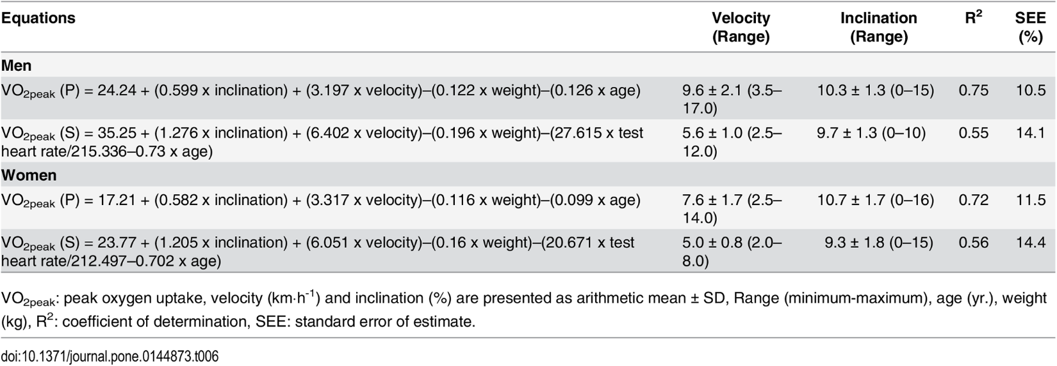

Table 4.2 - Loe, Nes and Wisløff table regarding the different equations used for VO2max prediction

Equation 4.3 - Uth, Sørensen, Overgaard, and Pedersen equation using the resting and maximal heartrate [33]

## Hearth rate equations used

As for the use of those equation in the application, because of the ease of use and due to the low number of variables in the 3rd type of equation, the one regarding correlation between the heartrate with the body being in a rest state and the maximal heartrate measured, the whole measurement algorithm will be based on that equation.

## Algorithms

As far as the processing of the data is concerned, that is composed of 2 main parts and uses 2 different algorithms.

The first part, which basically is a fitting of the coefficients that represent the areas of a certain exercise that can be modified, e.g. running on a treadmill will have 2 such coefficients being the speed at which the treadmill is set and its inclination. As such an algorithm for solving non-linear least square problems and optimizing the coefficients of a function, or to put in other words, to optimize the parameters of a certain model such that it fits certain observation made prior, is Gauss-Newton. This algorithm is similar to the gradient-based optimization method, but unlike it, it also takes into consideration information about the curvature of the function in addition to the slope, and because of the reliance on the curvature information it has the possibility to converge much faster to the minimum than a gradient descent approach [39].

The actual algorithm is based on Newton’s method that uses Hessian matrix, with a significant improvement, because of the high computational complexity of such a matrix, the Gauss-Newton algorithm uses a matrix by the same name that approximates it, thus reducing the computation of such a matrix and this is done by using the Moore–Penrose inverse.

Getting into more specifics, the main part of the algorithm consists of the update rule for the coefficients of the function found at Equation 4.4, where represents the updated coefficients, represents the current estimate of the coefficients, represents the pseudo invers of the Jacobian matrix, with the equation of computing it at Equation 4.5, and represents the residual vector for the current estimate of the coefficients.

Equation 4.4 - Gauss-Newton update rule

Equation 4.5 - Pseudo inverse of the Jacobian matrix

As such, because of the algorithm only depending on the coefficients of a function and a fitting function, the latter can be of any dimension, meaning that there is a lot of flexibility in the use of such an algorithm.

Finally, for the stopping condition for such an algorithm it does not include a maximum number of iterations, because of the nature of the function used it must always converge to a certain point, but works based on the Root-mean-square error, which is a method of measurement of the discrepancy between the predictive model and the actual data that is being processed. For this instance, because of the possible inaccuracy of the sensors and not precise measurements when it comes to defining a H.I.I.T. workout in terms of VO2max consumption, a tolerance difference of 5 was chosen.

The second part consists of a genetic algorithm that, based on the coefficients provided by the Gauss-Newton algorithm for the fitting function, that is fed back the processed data and tries to find the optimal variables, in regards to the H.I.I.T. workout paradigm, when in comes to the high and the low intensity part of the exercise, those being the 95% and the 20% VO2 consumption, the more simple equation being used Equation 4.3 to compute the current VO2 parameter and being proportionally compared to the VO2max, being calculated based on the prediction of the first algorithm.

This genetic or evolutionary algorithm uses a list representation of the desired variables and the fitness function for each individual is the same from the previous algorithm. The mutation rate, in which the variables are switched around randomly in the individual, is set at 0.2, because we want a high variance between the population. Generally, the maximum amount of iterations was set at 500, but a tolerance difference was also given in case the result is found faster. For the selection part, a tournament style selection was chosen with a sample size of 4, from which the best 2 are chosen based on their fitness. As for the breeding process, in which a new individual in created using the data from other 2, by using a number of cuts at which point the data is taken from the other parent. Finally, because the size of the population should stay constant between the generations, the least fit individual, after the creation of the new individual, is cut from the whole population.

This whole process repeats until the maximum number of iterations is achieved or until a result is found. After that, the variables are obtained for the certain parameters, the 95% and the 20% VO2 consumption.

# **Application**

## Motivation & Approach

The motivation for building more of a system than a single application was that I want to challenge myself to integrate as much of the knowledge I acquired along my university years and go out of my comfort zone, as I consider myself to be mainly a web developer that just tries different technologies, languages and environments just as personal side projects. Moreover, because of the more abstract nature of the subject and the little research done, there was a big challenge in designing and thinking of such a functional system that could actually produce palpable results. Even though physical work might be a pragmatic subject, the actual optimization and quantization of such work is more complex because the tools that we currently have at our disposal and the multitude of theoretical approaches. As such, much of the paper until now was based on the actual theory and the multiple approaches that can be taken.

Taking the complexity of the task to develop such an application into account, it was decided to split a whole application into 3 big parts and call it the whole more of a system than a single application with different parts. Because of this, big parts of the whole system can be replaced with a much better alternative, maybe a better optimization of the algorithms, better sensors, a more capable HDM with multiple extra features. As such, further work on such a subject can have a head start in regards to the implementation part. Furthermore, this approach may encourage other to pursue a more decoupled and open source approach when it comes to programming.

As a consequence of the decoupled approach of the implementation part, the whole principle of system can be used in combination with different types of physical exercises, the only difficulty in such a task being the identification of optimal number and category of the variables defining a workout, e.g. indoor cycling can be defined as the opposing force the pedals have, the speed at which the individual should pedal. A consequence of this can be the overparameterization, where the exercise is defined by too many variables and the performance of the whole algorithms stalls or even it may produce bad results, under parameterization, where because of the exercise is being described be enough important variables skewed results, and finally using the wrong parameters to define an exercise, leading to improper results. That being said, because of those disadvantages, there has to be a lot of care when deciding which aspects of an exercise are actually important.

On a more positive note, and also being another consequence of the chosen development approach, a VR equipment is replaceable with a device that gives suggestion to the user, instead of hiding that part by modifying the environment to fit the individual. This part can be explored in future research.

Finally, because of all the above points, the application needs to be taken more like a concept as there are a lot of improvements to be made on it, and there are a lot of areas that it can be expanded on.

## Technologies & Brief Description

In terms of the applications that are developed for this subject, there will be 3 base development phases regarding the 3 base applications. The description of the system used in the apps and the general architecture will be done in short, not going into too much detail, and more information about the applications and the system as a whole can be found in the next subchapters.

The first one that we will talk about is regarding the data collecting part. For the reason of simplicity and portability of such a device for the general public, this app will be developed on a Smart Watch, more specifically on a Samsung Gear S3 using the developer tools available and provided by Samsung, the Tizen IDE and API for the watch. Moreover, the application will be connected to a wireless network and will send the data regarding the current measurement of the heartbeat of the subject such that the server may receive them, process them, and in the end send them over to the VR environment where they will be used to adjust it to the intensity of the exercise.

The second application is a server that receives data from the measurement application and send them over to the VR one, or, as said in the previous chapter, to the part of the whole system that concerns itself with the execution and guidance of the user. This will be done using Flask as a base environment for developing it, where the means of communication with the VR app is through Web Sockets and the foundation for the web server will use Koa as a framework due to its lightweight nature. Also, in this part of the whole project most of the computation and processing of the data will be done regarding the until now intensity of the exercise and the efficiency of it. According to all the processed data and the structure of the exercise will try and manage the remaining parts of the exercise, upping the intensity or the duration, such that the basic parameters for a H.I.I.T workout are met. Moreover, the subjects input after such a workout will be considered when optimizing future uses, that data being stored in a database using the SQLAlchemy db framework for Python.

The last part is in regards to the VR environment, here the application will be a simple one, using an HDM (Head Mounted Display) and the hand controls for the spatial placement of the subject. This being said, the application will mimic a boxing match/training in which the intensity of the exercise can be upped with the use of multiple targets, requiring the subject to think and act more quickly as to hit as many targets as possible before they disappear, the placement of the targets in the environment being more far apart, requiring the subject to move more in order to complete the exercise, the time interval in which those appear and disappear, requiring a more quick reaction from the subject, while also being in a more ready state, and lastly incorporating some other difficult task to complete, e.g. incorporating some sort of jump mechanic in the middle of the exercise. This VR environment will be developed using Unity.

## System diagrams

For the system diagrams there will be one that will describe the whole system, and one for each one of the developed applications. Moreover, the diagrams represent the big technologies used and some of the big algorithms used with the emphasis on the communication between the different applications. In addition to this, there will be a short description for each one of those in order to detail them some more.

The first diagram Figure 5.1 describes the system as a whole with the more important technologies and algorithms for the 3 applications that compose it represented in rounded rectangles inside their respective application. In each part of the system, there is a text and in 2 of them there also a representative image of the actual devices. As for the connections between the applications those are represented by the arrows and their orientation, also on top of them there is the mechanism which provides the communication between the 2, by it unidirectional or bidirectional. 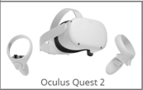

Figure 5.1 - Whole System Diagram

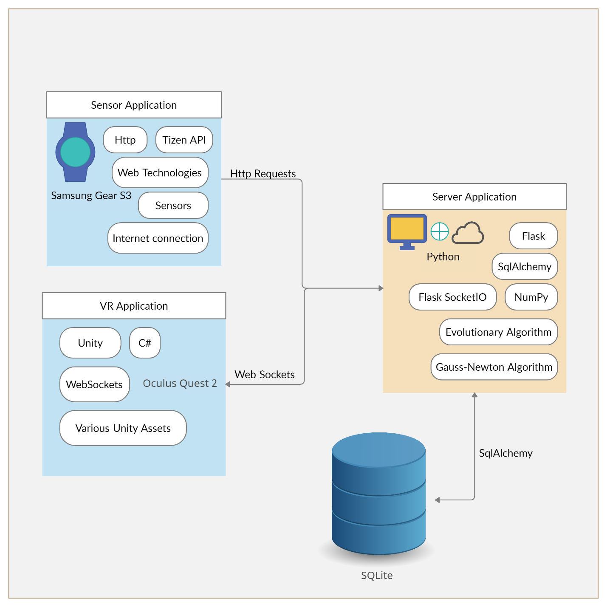

The second diagram Figure 5.2 describes the application in charge of the sensors. Being developed as a web-based application with an integration of Tizen API (API for accessing the watch’s information). In addition to this, the app uses the http protocol to send information to the server, that is decoupled from the actual application on the watch, as described in the section Motivation & Approach.

Figure 5.2 - Sensor Application

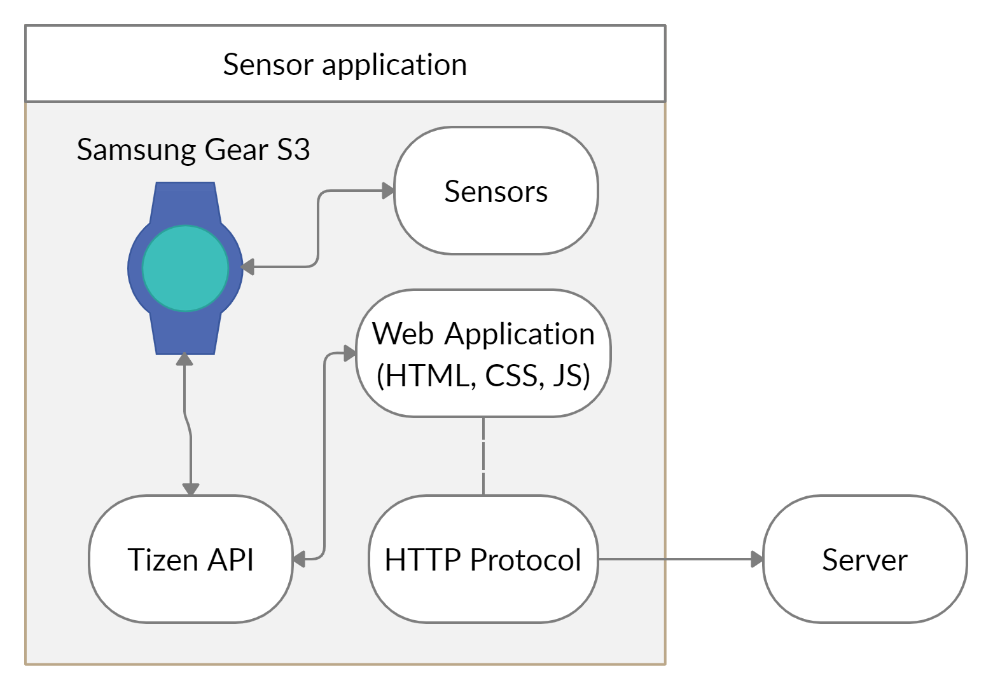

The third diagram Figure 5.3 describes the part of the whole system responsible for the communication between the rest of the parts. Moreover, it describes the different frameworks used and how those are used to interact between all the parts.

The forth and final diagram Figure 5.4 describes the part that guides the user on how to perform an exercise such that it fits the parameters computed in the server, in our case that being a VR application that adjust the environment according the calibration done by the user.

Figure 5.3 - Server Application

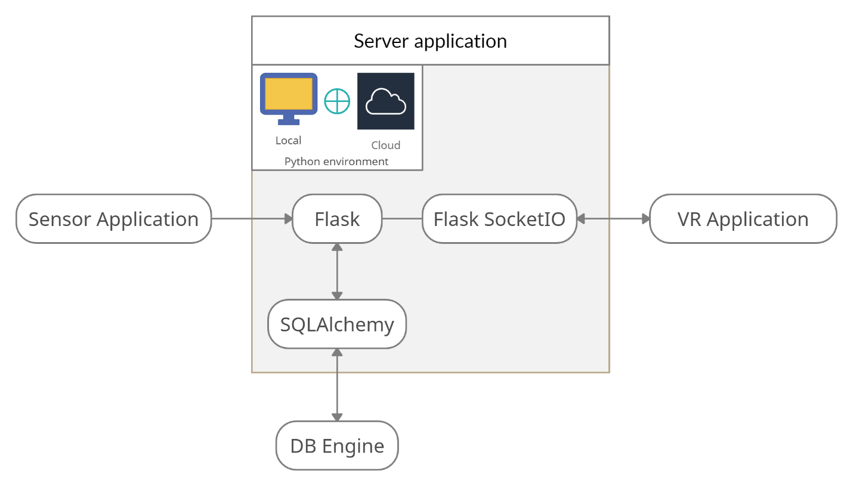

Figure 5.4 - VR Application

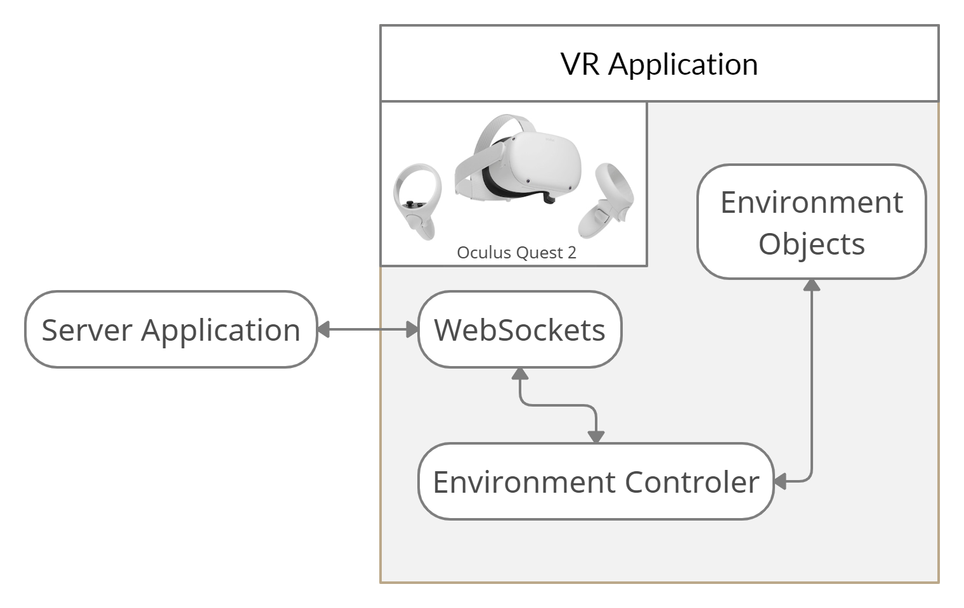

## System description

Because of the nature of the last chapter being about the system as a whole, detailing the connections between the different parts and how they all come together, in this chapter we will cover the parts in more depth and provide a more substantial description of the whole processes inside of them.

### Sensor Application

The main use case that this app fulfils is that it transmits the heartrate data to the server and it can also show the user the measurements, but that functionality is optional when implementing other systems like it, though it can be a good measure. Some of the features of this application are a hearth rate limiter Figure 5.5, that was added because of the specifics of the hardware use was a, such that whenever there is a spike in the measured hearth rate it does not register it, the integration with the Tizen API such that it can access the sensor for measuring the hearth rate of the wearer, the continuous display of the measured hearth rate Figure 5.5, and the sending of the collected data, through the http protocol.

Figure 5.5 - Hearth Rate Display & Limiter

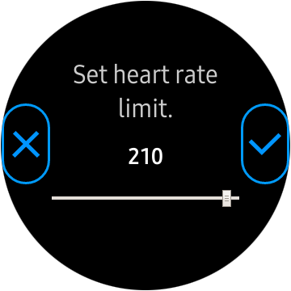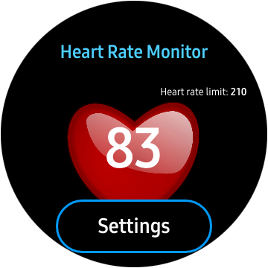

The cause for the limiter implementation was because of a bug in the accuracy of the sensor, this was due to the software used in the particular version of the TizenOS that the device has installed. The limiter can be accessed by pressing the Settings button on the main display screen, after which a slider with 2 buttons (confirm and cancel) appear, also the value of the limiter is displayed on the main screen.

Because of the aforementioned reason and because there is no actual official metric about the accuracy of this sensor, when it comes to the data a percentage error of about 5% was assumed for all the measurements when computing the data.

Another feature, only seen after first installing the application on a new device is the permission screen that appears, requiring the user to give access to the Hearth Rate Sensors and to Internet Access to the app.

A more basic system description can be seen in the use case diagram at Figure 5.7.

### Server Application

As said in the previous chapters, the main purpose the server application fulfils is that of procuring a means of communication between the rest of the system, while also processing the data received from the monitoring application, in this case being the watch sensor app, and optimizing the parameters of the exercise.

The communication between the sensor application and the server is done mainly by the http protocol, periodically receiving the hearth rate reading and locally storing that value, if there is at least one other device connected to the server thought web sockets, which should be the device that holds the application in charge of optimizing a certain exercise, in our case being a VR application.

Another important feature of the server is the one in charge of computing the data necessary during the calibration period of the VR application, this is done by starting a Scheduler that emits a trigger at a certain interval, in our case this interval was set to 5 seconds. Once the trigger was emitted, a handler, using the web socket, gets the parameters that were used during that interval in the VR application and stores them locally, while also computing a mean of all the hearth rate measurements, that were registered since the last scheduler trigger was emitted, by using an exponential incremental average described in Equation 5.1, where A is the computed average, v is the value of the current data point, computed using the average hearth rate as the maximal hearth rate in Equation 4.3, with the minimum being precalculated for the specific user at the time, and then dividing by the maximal vo2 to get how much it represents, and α is the constant representing the importance of the values to computing the next iteration average.

Equation 5.1 - Exponential Incremental Average Equation

Because the server can have multiple VR systems connected, an atomic counter is used to determine the number of current connections. Moreover, at the beginning of computing the actual VR environment parameters, past runs are considered, more specifically, the coefficients, and are weighted based on the user score, after which an average is done to get the coefficients for the current run. At the end they are fed back into the database as a new entry.

For the connection with the VR system, there are 2 main methods that get either the maximum, in our case being the 95% vo2max, and the minimum, 20% vo2max, values for the actual variables that describe the exercise, based on the previously computed coefficients. All of this is done using the Gauss-Newton Algorithm in combination with an Evolutionary Algorithm, which are more described in the Algorithms chapter.

The final feature is the storing of the coefficients along with a rating given by the user to the database, as to help future workouts be more consistent.

As a final note, the server app was developed, as it says in the Figure 5.3 using Python as the primary language, Flask as the main framework with Flask-SocketIO for the Web Socket part, in addition to NumPy for linear algebra and matrix computation for the AI algorithms.

A simplified and visual version of the description can be found at Figure 5.8.

### VR Application

As the VR application stands, its communication with the server is done mostly using Web Sockets and the HTTP protocol in Unity with C# for the scripts.

It includes a main menu, with a start exercise option and a quit option. The exercise in question can be compared to boxing training as it was described briefly in the chapter titled Technologies & Brief Description. It consists of the user trying to hit targets, using the VR controllers at his disposal that track hand movements. The targets become increasingly harder to hit and keep track of, as to increase the difficulty and intensity of the workout and make the user move more, thus burning more calories and consuming more energy, ergo, when talking from a H.I.I.T. view, making it more efficient. Because of the possibility of marketing it to a larger crowd, the whole process of optimizing the workout is hidden from the user.

One of the features of this application is the calibration part that comes before the actual workout, that is where most of the communication with the server is done. The app chooses random variables for the environment, only to then send them to the server at a fixed interval, this being server determined, as said in the previous chapter, after which the server compiles the data and sends back the values for the variables to use in the actual exercise. In case the calibration is consider to be faulty by the user, it can do it again. The whole calibration part takes around 120 seconds, as to acquire enough data from the individual.

The main part of the application consists of the actual exercise and it can be split into 2 main parts, the resting part and the high intensity one, as per described when talking about H.I.I.T. in the chapter Fitness & Health Terms.

The final part consists of the subjective rating of the individual of the actual session that has taken place, after which this rating is send back to the server.

All of this can be seen in the use case diagram at Figure 5.6.

Figure 5.6 - VR Application Use Case Diagram

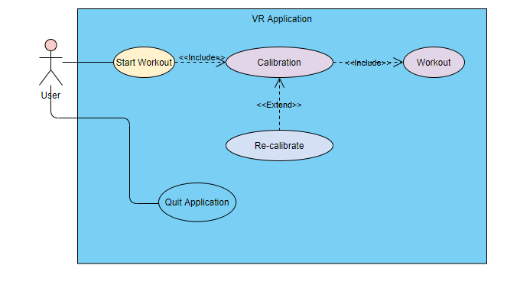

Figure 5.7 - Sensor Application Use Case Diagram

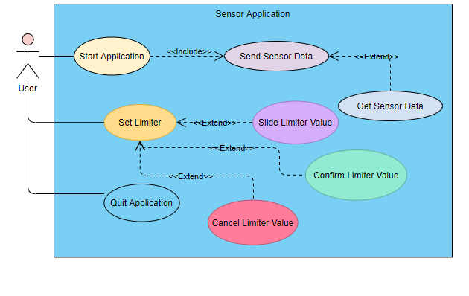

Figure 5.8 - Server Application Use Case Diagram

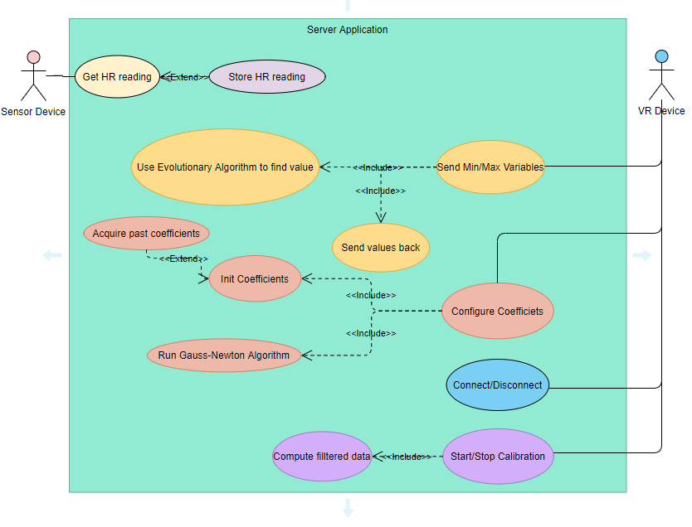

# **Evaluation**

## Data Collection

## Results

## Discussion

# **Conclusion**

# **Bibliography**

|  |  |
| --- | --- |
| [1] | Firstbeat Technologies, *Indirect EPOC Prediction Method Based on Heart Rate Measurement,* 2012. |
| [2] | E. W. Darren, W. N. Crystal and S. B. Shannon, "Health benefits of physical activity: the evidence," *CMAJ,* 2006. |
| [3] | B. Giovanni and P. Stefano, "The Effects of Physical Activity on Social Interactions: The Case of Trust and Trustworthiness," *Journal of Sports Economics,* vol. 20, no. 1, 2019. |
| [4] | R. Veenhoven, "Healthy happiness: effects of happiness on physical health and the consequences for preventive health care.," *Journal of Happiness Studies,* vol. 9, no. 3, 2007. |
| [5] | B. Kevin , "The Thrill of the Fight Game Review – The Ultimate VR Boxing Workout," VR Fitness Insider, 2019. |
| [6] | H. Shane, "How To Build A Full Body Beginner to Advanced Workout Routine With BOXVR," VR Fitness Insider, 2018. |
| [7] | J. Paglow, "Holopoint VR Game Review – Intense VR Archery Experience," VR Fitness Insider, 2018. |
| [8] | Sealost Interactive LLC, *The Thrill of the Fight,* Sealost Interactive LLC, 2019. |
| [9] | E. F. Azad, A. Alexander, C. Hamdi and S. Billy, "High-Intensity Interval Training Performed by Young Athletes: A Systematic Review and Meta-Analysis," *Frontiers in Physiology,* vol. 9, p. 1012, 2018. |
| [10] | P. Farinatti, A. Neto and N. L. da Silva, "Influence of Resistance Training Variables on Excess Postexercise Oxygen Consumption: A Systematic Review," 05 December 2012. [Online]. Available: https://www.hindawi.com/journals/isrn/2013/825026/. |
| [11] | L. Kravitz and J. Reynolds, "Resistance Training and EPOC," 2001. [Online]. Available: https://www.unm.edu/~lkravitz/Article%20folder/epoc.html. |
| [12] | E. Quinn, "VO2 Max Testing in Athletes," 24 May 2020. [Online]. Available: https://www.verywellfit.com/what-is-vo2-max-3120097#:~:text=VO2%20max%2C%20also%20known%20as,during%20the%20course%20of%20training.. |
| [13] | D. L. Tomlin and H. A. Wenger, "The relationship between aerobic fitness and recovery from high intensity intermittent exercise," 2001. [Online]. Available: https://pubmed.ncbi.nlm.nih.gov/11219498/. |
| [14] | T. Scribbans, S. Vecsey, P. Hankinson, W. Foster and B. Gurd, "The Effect of Training Intensity on VO2max in Young Healthy Adults: A Meta-Regression and Meta-Analysis," 1 April 2016. [Online]. Available: https://www.ncbi.nlm.nih.gov/pmc/articles/PMC4836566/. |
| [15] | I. Shigenori, "High-intensity interval training for health benefits and care of cardiac diseases - The key to an efficient exercise protocol," 26 July 2019. [Online]. Available: https://www.ncbi.nlm.nih.gov/pmc/articles/PMC6763680/. |
| [16] | J. Porcari, S. Dobres-Tein, C. Foster and T. Embers, "Exercise Intensity and Energy Expenditure of a Tabata Workout," 10 July 2013. [Online]. Available: https://www.ncbi.nlm.nih.gov/pmc/articles/PMC3772611/. |
| [17] | J. Laforgia, "Effects of exercise intensity and duration on the excess post-exercise oxygen consumption," December 2006. [Online]. Available: https://pubmed.ncbi.nlm.nih.gov/17101527/. |
| [18] | E. Quinn, "Should Endurance Athletes Avoid Weight Lifting?," 17 June 2020. [Online]. Available: https://www.verywellfit.com/should-endurance-athletes-lift-weights-3120588. |
| [19] | K. Weston, U. Wisløff and J. Coombes, "High-intensity interval training in patients with lifestyle-induced cardiometabolic disease: a systematic review and meta-analysis," 21 October 2013. [Online]. Available: https://bjsm.bmj.com/content/bjsports/48/16/1227.full.pdf. |
| [20] | I. Sutherland, "The Ultimate Display," in *IFIPS Congress*, New York, 1965. |
| [21] | H. Fuchs and G. Bishop, *Research Directions in Virtual Environments,* Chapel Hill: University of North Carolina , 1992. |
| [22] | P. Cipersso, G. Irine, M. Raya and G. Riva, "The Past, Present, and Future of Virtual and Augmented Reality Research: A Network and Cluster Analysis of the Literature," *Frontiers in Psychology,* vol. 9, p. 2089, 2016. |
| [23] | Software Testing Help, *VR Controllers And Accessories For An Immersive Experience,* Software Testing Help, 2021. |
| [24] | D. Fafard, I. Stavness, M. Dechant, R. Mandryk, Q. Zhou and S. Fels, "FTVR in VR: Evaluation of 3D Perception With a Simulated Volumetric Fish-Tank Virtual Reality Display," in *Association for Computing Machinery*, New York, 2019. |
| [25] | M. Lombard and T. Ditton, "At the Heart of It All: The Concept of Presence," *Journal of Computer-Mediated Communication,* vol. 3, no. 2, 1997. |
| [26] | J. Short, E. Williams and B. Christie, *The social psychology of telecommunications,* London, 1976. |
| [27] | C. Nolan, Director, *Inception.* [Film]. United States of America: Legendary Production, 2010. |
| [28] | F. Biocca and M. R. Levy, "Immersive Virtual Reality Technology," in *Communication in the Age of Virtual Reality*, New Jersey, Lawrence Erlbaum Associates, 1995. |
| [29] | J. Qian, D. McDonough and Z. Gao, "The Effectiveness of Virtual Reality Exercise on Individual’s Physiological, Psychological and Rehabilitative Outcomes: A Systematic Review," 29 April 2020. [Online]. Available: https://www.ncbi.nlm.nih.gov/pmc/articles/PMC7312871/. |
| [30] | BJRMD, *Firstbeat VO2 estimation - valid or voodoo?,* Muscle Oxygen Training blog, 2019. |
| [31] | P. O. Astrand and I. Rhyming, "A Nomogram for Calculation of Aerobic Capacity (Physical Fitness) From Pulse Rate During Submaximal Work," September 1954. [Online]. Available: https://journals.physiology.org/doi/pdf/10.1152/jappl.1954.7.2.218. |
| [32] | T. W. Storer, J. A. Davis and V. J. Caiozzo, "Accurate prediction of VO2max in cycle ergometry.," *Medicine and science in sports and exercise,* vol. 22, no. 5, 1990. |
| [33] | U. Niels, S. Henrik, O. Kristian and K. P. Preben, "Estimation of VO2max from the ratio between HRmax and HRrest--the Heart Rate Ratio Method," *European journal of applied physiology,* vol. 91, no. 1, 2004. |
| [34] | H. M. Moh, E. ,. Dale, J. ,. Terry, W. ,. Jared and W. ,. Travis, "Validity of VO2max equations for aerobically trained males and females," *Medicine and science in sports and exercise,* vol. 36, no. 8, pp. 1427-1432, 2004. |
| [35] | G. Alce, A. Hansson and K. Mårtensson, "Using VR for Fitness Training – Pilot Study," in *Virtual Reality and Augmented Reality*, Cham, Springer International Publishing, 2019, pp. 97-115. |
| [36] | E. Tuveri, L. Macis, F. Sorrentino, L. D. Spano and R. Scateni, "Fitmersive Games: Fitness Gamification through Immersive VR," in *Proceedings of the International Working Conference on Advanced Visual Interfaces*, Bari, Association for Computing Machinery, 2016, p. 212–215. |
| [37] | H. T. Lee and Y. S. Kim, "The effect of sports VR training for improving human body composition," *EURASIP Journal on Image and Video Processing,* vol. 2018, no. 1, 2018. |
| [38] | H. Loe, B. M. Nes and U. Wisløff, "Predicting VO2peak from Submaximal- and Peak Exercise Models: The HUNT 3 Fitness Study, Norway," *PLOS ONE,* vol. 11, p. 1020, 2016. |
| [39] | M. R. OSBORNE, "SEPARABLE LEAST SQUARES, VARIABLE PROJECTION, AND THE GAUSS-NEWTON ALGORITHM," *Electronic Transactions on Numerical Analysis,* vol. 28, no. 1068, pp. 1-15, 2007. |
| [40] | J. George, S. Paul, A. Hyde, D. Bradshaw, P. Vehrs, R. Hager and F. Yanowitz, "Prediction of Maximum Oxygen Uptake Using Both Exercise and Non-Exercise Data," *Measurement in Physical Education and Exercise Science,* vol. 13, pp. 1-12, 2009. |